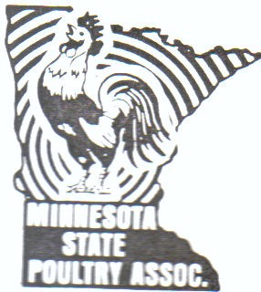
2026 Minnesota State Poultry Association Show Catalog
October 24-25, 2026, In Honor of Reynold Loecker
2026 Minnesota State Poultry Association Show Catalog  The Minnesota State Poultry Association invites all poultry fanciers from Canada and throughout the United States to exhibit your birds with us at our 138th Annual Show.  Location: 840 Century Avenue SW, Hutchinson, Minnesota.  Directions: Hutchinson is 50 miles west of Minneapolis. From 494, take State Hwy. #7 to Hutchinson, Main entrance is on Highway 15 South. Turn on Century Avenue behind the Shamrock Inn and Walmart.  MOTEL ACCOMMODATIONS IN HUTCHINSON:  - Days Inn (Headquarters) 1-320-587-6030  - Americ-Inn 1-320-587-5515  - King Motel 1-320-587-4737  - Queens Inn 1-320-587-2129  - Cobblestone Hotel and Suites 1-320-587-7777  - Shamrock Inn 1-320-587-9299  OFFICERS: President - Mark Petersen 1-507-340-5277  1st Vice President - Richard Andree 1-507-396-3804  2nd Vice President - Don Ryan 1-952-758-4007  Secretary-Treasurer - Patti Dietzel 1-952-303-9948  SHOW RULES AND REGULATIONS  1. Open entry fee is $5.00 per bird. Double coops are $10.00. Trios are $15.00. Junior entry fee is $4.00 per bird. Double coops are $8.00. Trios are $12.00  2. ENTRY DEADLINE OCTOBER 2, 2026  3. Absolutely NO scales in the showroom.  4. ALL ENTRIES must be accompanied by a valid negative pullorum/typhoid test certificate administered 90 days of the show or N.P.I.P certificate. All birds must meet Minnesota regulations for the exhibition including a leg band or wing band. Turkeys must be tested for Mycoplasm Gallisepticum and Mycoplasm Synovae.  5. All breeds that included bearded and non-bearded or single comb and rose comb varieties should be identified specifically.  6. A junior is a youth who is 18 and under. APA rules govern; Open Show is different birds.  7. The Minnesota State Poultry Association has accepted specialty meets from various clubs but will not be held responsible for such awards.  8. Birds are to be handled by the owner, judge and show officials only. Any person interfering with judging will have his/her birds disqualified.  9. All eggs laid during the show are property of Minnesota State Poultry Association. Only show officials are authorized to remove eggs from cages.  10. A display of chickens, turkeys and guineas will consist of cock, hen, cockerel, pullet and a young or old trio. A display in waterfowl will consist of old male, old female, young male, young female and 3 more birds. Point system per APA rules will govern.  2:00 p.m. Benefit Auction (all proceeds go to MSPA), raffle follows the auction.  5:30 p.m. Open Class Awards Social Hour starts with hor d'oeuvres, cake and light refreshments. Zeb Skow offers: 10 drawings of $10.00 each for those attending the Awards Social Hour.  SUNDAY, OCTOBER 25th:  7:00 a.m. Showroom opens  8:30 a.m. Junior Award presentation with Coop Out to follow.  MSPA offers on Sunday morning 3 - $20.00 cash drawings for open show exhibitors. One winner per family  SALES:  Sale coops will not be available inside the building for health and bio-security reasons. You must be an exhibitor to sell from your vehicle or trailer. The cost is $20.00, which should be paid for with your entry and your health papers.  MEETS:  AMERAUCANA ALLIANCE NATIONAL MEET  Ameraucana Alliance Club Meet Please visit our website and Ameraucana Forum: Ameraucana.org  In Open Show competition, with three or more birds in a class we offer …  - a ribbon for Best of Breed bantam  - a ribbon for Reserve of Breed bantam  - a ribbon for Best of Breed large fowl  - a ribbon for Reserve of Breed large fowl  AMERICAN BANTAM ASSOCIATION DISTRICT MEET  PO. Box 127 Augusta, New Jersey 07822 Phone/Fax: 1-973-383-8633 Email: fancybantams@embarqmail.com Website:  Personalized certificates to Champion and Reserve Champion Bantam  INTERNATIONAL WATERFOWL BREEDERS’ ASSOCIATION DISTRICT MEET  IWBA, 9419 Damrau RD, Amherst, Wisconsin 54406  PLYMOUTH ROCK FANCIERS CLUB STATE MEET  - Contact Cala McGregor  RHODE ISLAND RED CLUB OF AMERICA STATE MEET  The Rhode Island Red Club of America offers meets in order to boost the breeding, exhibiting and promotion of the most exceptional of all breeds, the Rhode Island Red. Only members in good standing may compete for points for the Red Club Master Exhibitor and Master Breeder Awards. To join the Rhode Island Red Club of America, send dues of $15.00 for adult ($20 US funds for foreign) or $5 for junior membership to Toni Candea, 130 Dunthorne Drive, Bloomingburg, New York 12721, 1-845-361-5178, tcandea@optonline.net. All members receive the Chronicle, the official club publication.  UNITED ORPINGTON CLUB DISTRICT MEET  Emily McCandless, Secretary, unitedorpington22@gmail.com. Phone 1-440-725-1900. District/Local contact: Beau Schacherer, 1-320-894-2388  COCHINS INTERNATIONAL MEET – SPECIAL MEET  The Minnesota State Poultry Association will present awards in the Junior Show and for the Showmanship Contest. A Junior is a youth who is 18 years of age or younger. The Junior Show will be SEPARATE from the open show. A Junior can also show in the open show with different birds.  MINNESOTA STATE POULTRY ASSOCIATION SHOW AWARDS  The Minnesota State Poultry Association proudly offers a wide variety of cash awards, plaques, medallions, rosettes, and other special recognitions across the Open and Junior Shows. A complete and current list of awards, including any additional sponsored awards, will be posted in the showroom prior to the start of judging.  Thank you to the families of Duane Urch and Richard Timm for their $50.00 donations for the Youth Drawing.  In appreciation, the MSPA will have a drawing for a one-night stay at Days Inn and 3 drawings of $20.00 for an adult who stays and helps set up or tear down the show.  Show Vendor:  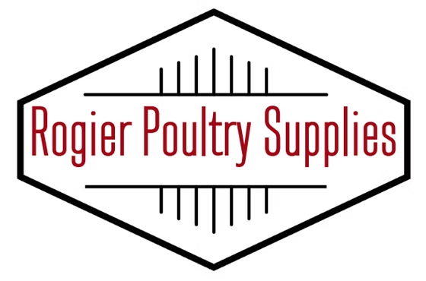 | 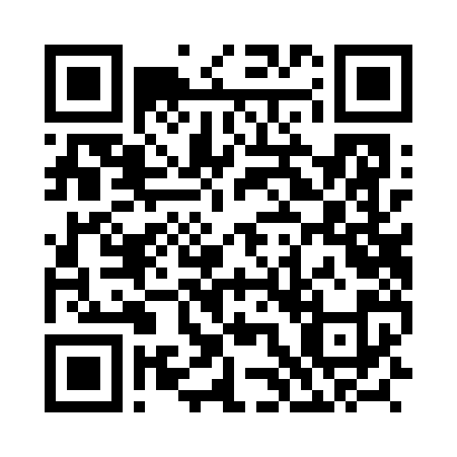  JUDGES - OPEN SHOW  - Jonathon Patterson, Indiana  - Brett Kreifers, Nebraska  - Zeb Skow, Iowa  - Cody Haefs, Minnesota  - Showmanship - Mike Kutzke, Minnesota  - Junior – Beau Schacherer, Minnesota  Show entries will be completed online through Poultry Hub and payment will be made via PayPal at the time of entry or by mailed check.  Exhibitor online URL https://poultry-hub.com/exhibitor/show/AiBm4n1wzYcvKdD1kMpJ or use QR code above  Only if you are unable to use the online entry form, send mail in entries to Nicole Peters 5605 Grimms Rd, Reedsville, WI 54230. 920-242-1412, npeters@tm.net  11. Building will be open on Friday, October 23rd at 11:00 a.m.- 10:00 p.m. All birds must be cooped in by 9:00 A.M., Saturday, October 24th. JUDGING BEGINS Saturday, October 24th at 9:00a.m. All birds must remain on exhibit until the awards have been given out on SUNDAY, October 25th.  12. American Poultry Association rules will govern this show. Any situation not provided for in these rules will be referred to by the Officers of the M.S.P.A. and their decision is final.  13. Geese will be cooped by pairs unless noted on entry.  14. Feed and water will be supplied, but all exhibitors will be responsible for the feeding and watering of their own birds.  15. ABSOLUTELY NO ENTRY CHANGES AT SHOWROOM. We are completely computerized. NO REFUNDS ON ENTRY FEES.  16. Camper fee is $35.00 per night, per grounds management. You must contact the fair office by October 19, 2026, to reserve camping space. 1-320-484-4301.  17. Any exhibitor leaving early without approval from management will NOT be allowed to show next year.  SHOW SCHEDULE:  FRIDAY, OCTOBER 23th:  The showroom will be open at 11:00 a.m. and close at 10:00 p.m. SHARP.  Annual MSPA Meeting in Meeting Room 7:30 pm  SATURDAY, OCTOBER 24th:  7:00 a.m. Showroom opens. Food truck available on Saturday starting at 7am.  9:00 a.m. Judging begins. Showmanship starts at 9:00 am.  In Junior competition, we offer …  - Ribbon for Best and Reserve of Breed bantam  - Ribbon for Best and Reserve of Breed large fowl  Only club members are eligible for awards offered by the club and Ameraucana Exhibitor Points. Members receive quarterly Ameraucana Newsletters and are registered members of the Ameraucana Forum. New, 1st time members receive an Ameraucana Handbook. Yearly dues are @10 (Newsletters emailed) or $17 (Newsletters mailed). We also offer a Special rate of just $25 for 3 years with Newsletters emailed.  Go to our website for more details and a membership form or request one from: Russell Blair 13100 S Adrian Hwy Jasper, MI 49248  WESTERN NATIONAL WYANDOTTE BREEDERS OF AMERICA NATIONAL MEET  wyandottebreedersofamerica@gmail.com Contact Caleb Englin for more information  AMERICAN POULTRY ASSOCIATION, INC. CLUB MEET  Becky Weaver, Secretary P.O. Box 205 Landisville, Pennsylvania 1-7538 1-717-279-1899 secretary@americanpoultryassn.com  The APA invites you to become a member. Annual dues are $20.00 for one (1) year, $50.00 for three (3) years; $25.00 for one year outside the U.S. and Canada; Junior Dues (for those 18 and under) are $15.00 per year or $40.00 for 3 years; Endowment Trust Life membership is $365.00. All Annual and Endowment Trust Life members receive our yearbook and are eligible to earn points toward a Master Exhibitor Award. Every member is eligible for the awards at this show.  - Special APA medals for Show Champion and Show Reserve  - PA minimum of five (5) Master Exhibitor Award points will be awarded to any qualified win at this show. APA ribbons awarded  JUNIOR SHOW:  Entry Fee: $4.00 - Single Bird, $8.00 - Double Coop, $12.00 - Trio  JUDGING: SATURDAY, OCTOBER 24th 9:00 A.M.  SHOWMANSHIP CONTEST: Saturday, October 24th, 9:00 A.M.  Each Junior must bring one bird of their choice (Chicken, Duck, Goose or Turkey) to the ring to be judged. YOU, the exhibitor, will be judged on the appearance of your bird, your knowledge of the bird, how you handle the bird and your general poultry enthusiasm. We will have seating and a sound system so all can hear and see the placings.  We prefer you pre-register on your entry to be in the showmanship contest. There is no entry fee for showmanship.  Be sure to include your age group on your entry. You must bring an extra bird for showmanship. This will allow the Junior Judge to finish each class uninterrupted. This bird can be borrowed from a friend.  - Age groups are:  - 9 years and under  - 10-14 years  - 15-18 years of age  - Be sure to include your age group on your entry. You must bring an extra bird for showmanship. This will allow the Junior Judge to finish each class uninterrupted. This bird can be borrowed from a friend.  The Junior show will be held in the Agribition Building. All judging will be by the latest edition of the American Standard of Perfection copyrighted by the American Poultry Association, Inc. Application for membership maybe made at the show or may be sent to the American Poultry Association but must be prior to judging to be eligible for the APA awards.  Sponsors:  